Los Angeles County: Preventing Youth Suicide
August 2018

Advancing Evidence-Informed Policy to Improve Youth Outcomes

*Includes death by hanging
Suicide is Preventable
Suicide is the 3rd leading cause of death among Los Angeles County youth 15-24 years of age. The highest rates of suicide attempts are found among this same age group.

An essential building block for comprehensive suicide prevention includes fostering community networks and social connections across the lifespan to have the greatest impact in reducing suicide deaths, suicide attempts, and all forms of self-harm. This is particularly important for youth.

Los Angeles County Data Snapshot – 2012 to 2014

Youth and young adults (10-24 years old) accounted for 258 suicide deaths, over 4,200 hospitalizations and nearly 4,000 Emergency Department visits for suicide attempts.

Demographics of Youth Victims of Suicide and
Suicide Attempts* in Los Angeles County

 | Deaths | Inpatient | ED Visit
Total # | 258 | 4,239 | 3,916
Male | 75% | 35% | 39%
Female | 25% | 65% | 61%
White | 24% | 30% | 29%
Black | 12% | 10% | 13%
Latino | 50% | 51% | 47%
Asian/PI | 14% | 5% | 4%
10-14 YEARS | 5% | 16% | 18%
15-19 YEARS | 30% | 44% | 45%
20-24 YEARS | 65% | 39% | 37%
Suffocation | 46% | ---* | ---*
Firearm | 24% | ---* | ---*
Poison | 12% | 59% | 45%
Cut/ Stabbing | ---* | 31% | 32%
* Small cell size or information not available.

Between 2007 and 2016, the youth suicide rate ranged from
3.4 to 4.8 deaths per 100,000.

*Suicide attempts with reported treatment and release from an Emergency Department or requiring Hospitalization.

Data Sources
Mortality data are from the California Department of Public Health, provided by the Office of Health Assessment & Epidemiology in the Los Angeles County Department of Public Health. Non-fatal injury data are from the Office of Statewide Health Planning & Development in California.

Mortality data are available through 2016, but non-fatal injury data are currently available only through 2014.

Preventing suicide begins with teaching, establishing and maintaining physical, emotional, and mental well-being

We All Play a Role in Preventing Suicide:
- Know the Warning Signs
- Take the Person Seriously
- Listen with Empathy and Provide Support
- Make a Safety Plan, reduce easy aces to lethal means (firearms, medications, etc.)
- Do Not Keep Suicide Secrets - tell a trusted adult, seek professional help

Public Health Focus on Suicide Prevention: Considerations for Youth
While the exact number of suicide attempts is unknown;
researchers have estimated
that there are roughly

25 suicide attempts
made for every
single completed suicide

(American Association of Suicidology, 2007).

Protective factors:
- Social connectedness
- Exposure to responsible (non-glamourized) media reporting on suicide
- Access to effective clinical interventions (therapeutic, behavioral, and medical)
- Emotion regulation, problem solving and conflict resolution skills
- Reduced stigma (individual, family, and community)
- Restricted access to lethal means (firearms, stockpiled medications, etc.)
- Positive beliefs about the future, ability to cope, and life in general
- Strong support systems
Risk Factors:
- Unmanaged mood and anxiety disorders, impulsivity
- Current or past exposure to violence, abuse, or trauma
- Previous suicide attempts or self-inflicted injury
- Bullying
- Family or peer history of suicide
- Alcohol and drug abuse
- Bereavement
- Academic troubles/failure
- Isolation
- Relationship stressors (dating, peers, family, etc.)
- Hopelessness
- Pattern of aggressive or antisocial behavior

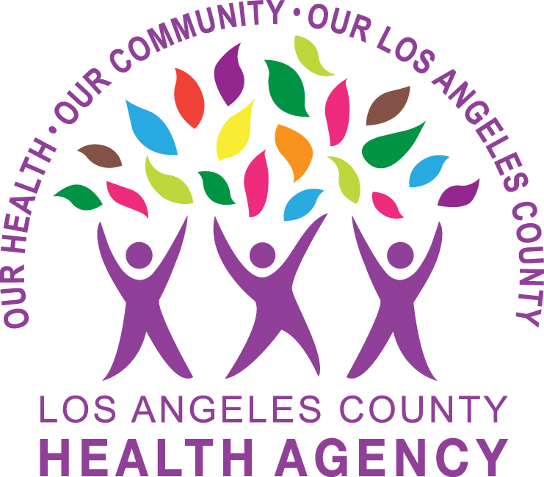
Resources and Support for Youth:
- LA County 211 www.211la.org
- LA County Department of Mental Health 1-800-854-7771
- Teen Line – 310-855-4673, teenlineonline.org text TEEN to 839863
- Trevor Project - Lifeline 1-866-488-7386, thetrevorproject.org Text (TREVOR to 1-202-304-1200)
- Los Angeles LGBT Center lalgbtcenter.org
- Active Minds https://www.activeminds.org
- Know the Signs www.suicideispreventable.org
- Love Is Respect 1-866-331-9474 https://www.loveisrespect.org, text LOVEIS to 22522
- National Suicide Prevention Lifeline at 1-800-273-TALK (8255) or visit suicidepreventionlifeline.org/help-yourself/youth and
youmatter.suicidepreventionlifeline.org

